# 17a. Machine Learning Using Redshift ML - Data Analyst

In this lab you will create a model using Redshift ML Auto.

## [Contents](https://catalog.us-east-1.prod.workshops.aws/v2/workshops/9f29cdba-66c0-445e-8cbb-28a092cb5ba7/en-US/lab17a" \l "contents)

* [Contents](https://catalog.us-east-1.prod.workshops.aws/v2/workshops/9f29cdba-66c0-445e-8cbb-28a092cb5ba7/en-US/lab17a#contents)
* [Before You Begin](https://catalog.us-east-1.prod.workshops.aws/v2/workshops/9f29cdba-66c0-445e-8cbb-28a092cb5ba7/en-US/lab17a#before-you-begin)
* [Data Preparation](https://catalog.us-east-1.prod.workshops.aws/v2/workshops/9f29cdba-66c0-445e-8cbb-28a092cb5ba7/en-US/lab17a#data-preparation)
  + [Attribute Information /Input variables / bank client data:](https://catalog.us-east-1.prod.workshops.aws/v2/workshops/9f29cdba-66c0-445e-8cbb-28a092cb5ba7/en-US/lab17a#attribute-information-input-variables--bank-client-data)
  + [Output variable (desired target):](https://catalog.us-east-1.prod.workshops.aws/v2/workshops/9f29cdba-66c0-445e-8cbb-28a092cb5ba7/en-US/lab17a#output-variable-desired-target)
* [Create Model](https://catalog.us-east-1.prod.workshops.aws/v2/workshops/9f29cdba-66c0-445e-8cbb-28a092cb5ba7/en-US/lab17a#create-model)
* [Check Accuracy and Run Inferance Query](https://catalog.us-east-1.prod.workshops.aws/v2/workshops/9f29cdba-66c0-445e-8cbb-28a092cb5ba7/en-US/lab17a#check-accuracy-and-run-inferance-query)
* [Before You Leave](https://catalog.us-east-1.prod.workshops.aws/v2/workshops/9f29cdba-66c0-445e-8cbb-28a092cb5ba7/en-US/lab17a#before-you-leave)

## [Before You Begin](https://catalog.us-east-1.prod.workshops.aws/v2/workshops/9f29cdba-66c0-445e-8cbb-28a092cb5ba7/en-US/lab17a" \l "before-you-begin)

This lab assumes you have launched a Redshift cluster. If you have not launched a Redshift cluster see [LAB 1 - Creating Redshift Clusters](https://catalog.us-east-1.prod.workshops.aws/v2/workshops/9f29cdba-66c0-445e-8cbb-28a092cb5ba7/en-US/lab1.html). We will use the Redshift Query Editor in the Redshift console for this lab.

## [Data Preparation](https://catalog.us-east-1.prod.workshops.aws/v2/workshops/9f29cdba-66c0-445e-8cbb-28a092cb5ba7/en-US/lab17a" \l "data-preparation)

Data Set Information: Bank Marketing data set The data is related with direct marketing campaigns of a Portuguese banking institution. The marketing campaigns were based on phone calls. Often, more than one contact to the same client was required, in order to access if the product (bank term deposit) would be ('yes') or not ('no') subscribed.

The classification goal is to predict if the client will subscribe (yes/no) a term deposit (variable y).

#### [Attribute Information /Input variables / bank client data:](https://catalog.us-east-1.prod.workshops.aws/v2/workshops/9f29cdba-66c0-445e-8cbb-28a092cb5ba7/en-US/lab17a" \l "attribute-information-input-variables-bank-client-data:)

1. age (numeric)
2. job
3. marital
4. education
5. default
6. housing
7. loan
8. contact
9. month
10. day_of_week
11. duration
12. campaign
13. pdays
14. previous
15. poutcome
16. emp.var.rate
17. cons.price.idx
18. cons.conf.idx
19. euribor3m
20. nr.employed

#### [Output variable (desired target):](https://catalog.us-east-1.prod.workshops.aws/v2/workshops/9f29cdba-66c0-445e-8cbb-28a092cb5ba7/en-US/lab17a" \l "output-variable-(desired-target):)

1. y

Definition: has the client subscribed a term deposit? (binary: 'yes','no')

**Reference**: <https://archive.ics.uci.edu/ml/datasets/bank+marketing>

1. Execute the following statements to create and load the training and inference tables in Redshift. The training data is used to create the model and the inference data is used to make predictions.

CREATE TABLE bank_details_training(

age numeric,

job varchar,

marital varchar,

education varchar,

"default" varchar,

housing varchar,

loan varchar,

contact varchar,

month varchar,

day_of_week varchar,

duration numeric,

campaign numeric,

pdays numeric,

previous numeric,

poutcome varchar,

emp_var_rate numeric,

cons_price_idx numeric,

cons_conf_idx numeric,

euribor3m numeric,

nr_employed numeric,

y boolean ) ;

COPY bank_details_training from 's3://redshift-downloads/redshift-ml/workshop/bank-marketing-data/training_data/' REGION 'us-east-1' IAM_ROLE '<< REPLACE IAM_ROLE >> ' CSV IGNOREHEADER 1 delimiter ';';

CREATE TABLE bank_details_inference(

age numeric,

job varchar,

marital varchar,

education varchar,

"default" varchar,

housing varchar,

loan varchar,

contact varchar,

month varchar,

day_of_week varchar,

duration numeric,

campaign numeric,

pdays numeric,

previous numeric,

poutcome varchar,

emp_var_rate numeric,

cons_price_idx numeric,

cons_conf_idx numeric,

euribor3m numeric,

nr_employed numeric,

y boolean ) ;

COPY bank_details_inference from 's3://redshift-downloads/redshift-ml/workshop/bank-marketing-data/inference_data/' REGION 'us-east-1' IAM_ROLE '<< REPLACE IAM_ROLE >>' CSV IGNOREHEADER 1 delimiter ';';

## [Create Model](https://catalog.us-east-1.prod.workshops.aws/v2/workshops/9f29cdba-66c0-445e-8cbb-28a092cb5ba7/en-US/lab17a" \l "create-model)

The create model will take ~ 60 minutes to run.

Complete Autopilot generated with minimal user inputs This will be a binary classification problem but auto pilot will choose the relevant algorithm based on the data and inputs

1. Execute the following statement to create the model

DROP MODEL model_bank_marketing;

CREATE MODEL model_bank_marketing

FROM (

SELECT

age ,

job ,

marital ,

education ,

"default" ,

housing ,

loan ,

contact ,

month ,

day_of_week ,

duration ,

campaign ,

pdays ,

previous ,

poutcome ,

emp_var_rate ,

cons_price_idx ,

cons_conf_idx ,

euribor3m ,

nr_employed ,

y

FROM

bank_details_training )

TARGET y

FUNCTION func_model_bank_marketing

IAM_ROLE '<< REPLACE IAM_ROLE >>'

SETTINGS (

S3_BUCKET '<< REPLACE S3 bucket >>',

MAX_RUNTIME 3600

)

;

## [Check Accuracy and Run Inference Query](https://catalog.us-east-1.prod.workshops.aws/v2/workshops/9f29cdba-66c0-445e-8cbb-28a092cb5ba7/en-US/lab17a" \l "check-accuracy-and-run-inference-query)

1. Next, run the following SQL Query to get some information about your model. Note the model state should say 'Ready'. Pay attention to the validation:f1 score - it will be between 0 and 1, the closer to 1, the better the model.

1

show model model_bank_marketing;

1. Check Inference/Accuracy of the model.

Run the following queries - the first checks the accuracy of the model and the second will use the function created by the pre built model for the inference and against the data set in inference table bank_details_inference.

--Inference/Accuracy on inference dats

WITH infer_data

AS (

SELECT y as actual, func_model_bank_marketing(age,job,marital,education,"default",housing,loan,contact,month,day_of_week,duration,campaign,pdays,previous,poutcome,emp_var_rate,cons_price_idx,cons_conf_idx,euribor3m,nr_employed) AS predicted,

CASE WHEN actual = predicted THEN 1::INT

ELSE 0::INT END AS correct

FROM bank_details_inference

),

aggr_data AS (

SELECT SUM(correct) as num_correct, COUNT(*) as total FROM infer_data

)

SELECT (num_correct::float/total::float) AS accuracy FROM aggr_data;

--Predict how many will subscribe for term deposit vs not subscribe

WITH term_data AS ( SELECT func_model_bank_marketing( age,job,marital,education,"default",housing,loan,contact,month,day_of_week,duration,campaign,pdays,previous,poutcome,emp_var_rate,cons_price_idx,cons_conf_idx,euribor3m,nr_employed) AS predicted

FROM bank_details_inference )

SELECT

CASE WHEN predicted = 'Y' THEN 'Yes-will-do-a-term-deposit'

WHEN predicted = 'N' THEN 'No-term-deposit'

ELSE 'Neither' END as deposit_prediction,

COUNT(1) AS count

from term_data GROUP BY 1;

## [Before You Leave](https://catalog.us-east-1.prod.workshops.aws/v2/workshops/9f29cdba-66c0-445e-8cbb-28a092cb5ba7/en-US/lab17a" \l "before-you-leave)

If you are done using your cluster, please think about decommissioning it to avoid having to pay for unused resources

# 17b. Machine Learning Using Redshift ML - Advanced Data Analyst

In this lab you will create a model using Redshift ML and provide the PROBLEM_TYPE and OBJECTIVE.

## [Contents](https://catalog.us-east-1.prod.workshops.aws/v2/workshops/9f29cdba-66c0-445e-8cbb-28a092cb5ba7/en-US/lab17b" \l "contents)

* [Contents](https://catalog.us-east-1.prod.workshops.aws/v2/workshops/9f29cdba-66c0-445e-8cbb-28a092cb5ba7/en-US/lab17b#contents)
* [Before You Begin](https://catalog.us-east-1.prod.workshops.aws/v2/workshops/9f29cdba-66c0-445e-8cbb-28a092cb5ba7/en-US/lab17b#before-you-begin)
* [Data Preparation](https://catalog.us-east-1.prod.workshops.aws/v2/workshops/9f29cdba-66c0-445e-8cbb-28a092cb5ba7/en-US/lab17b#data-preparation)
* [Create Model](https://catalog.us-east-1.prod.workshops.aws/v2/workshops/9f29cdba-66c0-445e-8cbb-28a092cb5ba7/en-US/lab17b#create-model)
* [Check Accuracy and Run Inferance Query](https://catalog.us-east-1.prod.workshops.aws/v2/workshops/9f29cdba-66c0-445e-8cbb-28a092cb5ba7/en-US/lab17b#check-accuracy-and-run-inferance-query)
* [Before You Leave](https://catalog.us-east-1.prod.workshops.aws/v2/workshops/9f29cdba-66c0-445e-8cbb-28a092cb5ba7/en-US/lab17b#before-you-leave)

## [Before You Begin](https://catalog.us-east-1.prod.workshops.aws/v2/workshops/9f29cdba-66c0-445e-8cbb-28a092cb5ba7/en-US/lab17b" \l "before-you-begin)

This lab assumes you have launched a Redshift cluster. If you have not launched a Redshift cluster see [LAB 1 - Creating Redshift Clusters](https://catalog.us-east-1.prod.workshops.aws/v2/workshops/9f29cdba-66c0-445e-8cbb-28a092cb5ba7/en-US/lab1.html). We will use the Redshift Query Editor in the Redshift console for this lab.

## [Data Preparation](https://catalog.us-east-1.prod.workshops.aws/v2/workshops/9f29cdba-66c0-445e-8cbb-28a092cb5ba7/en-US/lab17b" \l "data-preparation)

Data Set Information: <https://archive.ics.uci.edu/ml/datasets/iris>

This is perhaps the best known database to be found in the pattern recognition literature. Fisher's paper is a classic in the field and is referenced frequently to this day. (See Duda & Hart, for example.) The data set contains 3 classes of 50 instances each, where each class refers to a type of iris plant. One class is linearly separable from the other 2; the latter are NOT linearly separable from each other.

Predicted attribute: class of iris plant.

This is an exceedingly simple domain.

This data differs from the data presented in Fishers article (identified by Steve Chadwick, spchadwick '@' espeedaz.net ). The 35th sample should be: 4.9,3.1,1.5,0.2,"Iris-setosa" where the error is in the fourth feature. The 38th sample: 4.9,3.6,1.4,0.1,"Iris-setosa" where the errors are in the second and third features.

Attribute Information:

1. sepal length in cm
2. sepal width in cm
3. petal length in cm
4. petal width in cm
5. class

* Iris Setosa

* Iris Versicolour

* Iris Virginica

1. Execute the following statements to create and load the training and inference tables in Redshift. The training data is used to create the model and the inference data is used to make predictions.

DROP TABLE IF EXISTS iris_data_train;

CREATE TABLE iris_data_train (

Id int,

SepalLengthCm float,

SepalWidthCm float,

PetalLengthCm float,

PetalWidthCm float,

Species varchar(15)

);

COPY iris_data_train from 's3://redshift-downloads/redshift-ml/workshop/iris-data/train/' REGION 'us-east-1' IAM_ROLE '<< REPLACE IAM_ROLE >>' CSV IGNOREHEADER 1 ;

DROP TABLE IF EXISTS iris_data_test;

CREATE TABLE iris_data_test (

Id int,

SepalLengthCm float,

SepalWidthCm float,

PetalLengthCm float,

PetalWidthCm float,

Species varchar(15)

);

COPY iris_data_test from 's3://redshift-downloads/redshift-ml/workshop/iris-data/test/' REGION 'us-east-1' IAM_ROLE '<< REPLACE IAM_ROLE >>' CSV IGNOREHEADER 1 ;

## [Create Model](https://catalog.us-east-1.prod.workshops.aws/v2/workshops/9f29cdba-66c0-445e-8cbb-28a092cb5ba7/en-US/lab17b" \l "create-model)

The create model will take ~ 30 minutes to run.

User creates model and supplies some information like the PROBLEM_TYPE and OBJECTIVE as part of the create model process

Create model uses SageMaker Autopilot and chooses specified PROBLEM_TYPE and OBJECTIVE without trying out other options

PROBLEM_TYPE - multiclass classification , for all problem_types supported by SageMaker Autopilot - <https://docs.aws.amazon.com/sagemaker/latest/dg/autopilot-automate-model-development-problem-types.html>

OBJECTIVE - accuracy , for all objectives for xgboost : <https://xgboost.readthedocs.io/en/latest/parameter.html#learning-task-parameters>

1. Execute the following statement to create the model

CREATE MODEL model_iris

FROM (

SELECT

Id,

SepalLengthCm,

SepalWidthCm,

PetalLengthCm,

PetalWidthCm,

Species

FROM iris_data_train

)

TARGET Species

FUNCTION func_model_iris IAM_ROLE '<< REPLACE IAM_ROLE >>'

PROBLEM_TYPE multiclass_classification

OBJECTIVE 'accuracy'

SETTINGS (S3_BUCKET '<< REPLACE S3 bucket >>',

MAX_RUNTIME 1800 );

;

## [Check Accuracy and Run Inferance Query](https://catalog.us-east-1.prod.workshops.aws/v2/workshops/9f29cdba-66c0-445e-8cbb-28a092cb5ba7/en-US/lab17b" \l "check-accuracy-and-run-inferance-query)

1. Next, run the following SQL Query to get some information about your model. Note the model state should say 'Ready'.

1

show model model_iris;

1. Check Inference/Accuracy of the model.

Run the following queries - the first checks the accuracy of the model and the second will use the function created by the pre built model for the inference and against the data set in inference table.

--Check Model Accuracy

WITH infer_data AS (

SELECT Species AS label,

func_model_iris(Id, SepalLengthCm, SepalWidthCm, PetalLengthCm, PetalWidthCm) AS predicted,

CASE WHEN label is NULL THEN NULL ELSE label END AS actual,

CASE WHEN actual = predicted THEN 1::INT

ELSE 0::INT END AS correct

FROM iris_data_test

),

aggr_data AS (

SELECT SUM(correct) as num_correct, COUNT(*) as total FROM infer_data

)

SELECT (num_correct::float/total::float) AS accuracy FROM aggr_data;

--Predict the class of iris flower

WITH class_data AS ( SELECT func_model_iris(

Id,

SepalLengthCm,

SepalWidthCm,

PetalLengthCm,

PetalWidthCm) AS class

FROM iris_data_test )

SELECT

CASE WHEN class = 'Iris-versicolor' THEN 'Class-Iris-versicolor'

WHEN class = 'Iris-setosa' THEN 'Class-Iris-setosa'

WHEN class = 'Iris-virginica' THEN 'Class-Iris-virginica'

ELSE 'Class-Other' END as class_distribution,

COUNT(1) AS count

from class_data GROUP BY 1;

## [Before You Leave](https://catalog.us-east-1.prod.workshops.aws/v2/workshops/9f29cdba-66c0-445e-8cbb-28a092cb5ba7/en-US/lab17b" \l "before-you-leave)

If you are done using your cluster, please think about decommissioning it to avoid having to pay for unused resources

# 17c. Machine Learning Using Redshift ML - Data Scientist

In this lab you will create a model using Redshift ML and provide the MODEL_TYPE , OBJECTIVE, PREPROCESSORS and HYPER PARAMETERS.

## [Contents](https://catalog.us-east-1.prod.workshops.aws/v2/workshops/9f29cdba-66c0-445e-8cbb-28a092cb5ba7/en-US/lab17c" \l "contents)

* [Contents](https://catalog.us-east-1.prod.workshops.aws/v2/workshops/9f29cdba-66c0-445e-8cbb-28a092cb5ba7/en-US/lab17c#contents)
* [Before You Begin](https://catalog.us-east-1.prod.workshops.aws/v2/workshops/9f29cdba-66c0-445e-8cbb-28a092cb5ba7/en-US/lab17c#before-you-begin)
* [Data Preparation](https://catalog.us-east-1.prod.workshops.aws/v2/workshops/9f29cdba-66c0-445e-8cbb-28a092cb5ba7/en-US/lab17c#data-preparation)
* [Create Model](https://catalog.us-east-1.prod.workshops.aws/v2/workshops/9f29cdba-66c0-445e-8cbb-28a092cb5ba7/en-US/lab17c#create-model)
* [Check Accuracy and Run Inferance Query](https://catalog.us-east-1.prod.workshops.aws/v2/workshops/9f29cdba-66c0-445e-8cbb-28a092cb5ba7/en-US/lab17c#check-accuracy-and-run-inferance-query)
* [Before You Leave](https://catalog.us-east-1.prod.workshops.aws/v2/workshops/9f29cdba-66c0-445e-8cbb-28a092cb5ba7/en-US/lab17c#before-you-leave)

## [Before You Begin](https://catalog.us-east-1.prod.workshops.aws/v2/workshops/9f29cdba-66c0-445e-8cbb-28a092cb5ba7/en-US/lab17c" \l "before-you-begin)

This lab assumes you have launched a Redshift cluster. If you have not launched a Redshift cluster see [LAB 1 - Creating Redshift Clusters](https://catalog.us-east-1.prod.workshops.aws/v2/workshops/9f29cdba-66c0-445e-8cbb-28a092cb5ba7/en-US/lab1.html). We will use the Redshift Query Editor in the Redshift console for this lab.

## [Data Preparation](https://catalog.us-east-1.prod.workshops.aws/v2/workshops/9f29cdba-66c0-445e-8cbb-28a092cb5ba7/en-US/lab17c" \l "data-preparation)

Predicting the age of abalone from physical measurements. The age of abalone is determined by cutting the shell through the cone, staining it, and counting the number of rings through a microscope -- a boring and time-consuming task. Other measurements, which are easier to obtain, are used to predict the age. Further information, such as weather patterns and location (hence food availability) may be required to solve the problem.

From the original data examples with missing values were removed (the majority having the predicted value missing), and the ranges of the continuous values have been scaled for use with an ANN (by dividing by 200).

Attribute Information:

Given is the attribute name, attribute type, the measurement unit and a brief description. The number of rings is the value to predict: either as a continuous value or as a classification problem.

| **Name** | **Data Type** | **Measurement Unit** | **Description** |
| --- | --- | --- | --- |
| Sex | nominal | -- | M, F, and I (infant) |
| Length | continuous | mm | Longest shell measurement |
| Diameter | continuous | mm | perpendicular to length |
| Height | continuous | mm | with meat in shell |
| Whole weight | continuous | grams | whole abalone |
| Shucked weight | continuous | grams | weight of meat |
| Viscera weight | continuous | grams | gut weight (after bleeding) |
| Shell weight | continuous | grams | after being dried |
| Rings | integer | -- | +1.5 gives the age in years |

Reference : <https://archive.ics.uci.edu/ml/datasets/Abalone>

1. Execute the following statements to create and load the training and inference tables in Redshift. The training data is used to create the model and the inference data is used to make predictions.

DROP TABLE IF EXISTS abalone_xgb_train;

CREATE TABLE abalone_xgb_train (

length_val float,

diameter float,

height float,

whole_weight float,

shucked_weight float,

viscera_weight float,

shell_weight float,

rings int

);

COPY abalone_xgb_train FROM 's3://redshift-downloads/redshift-ml/workshop/xgboost_abalone_data/train/' REGION 'us-east-1' IAM_ROLE '<< REPLACE IAM_ROLE >>' IGNOREHEADER 1 CSV;

DROP TABLE IF EXISTS abalone_xgb_test;

CREATE TABLE abalone_xgb_test (

length_val float,

diameter float,

height float,

whole_weight float,

shucked_weight float,

viscera_weight float,

shell_weight float,

rings int

);

COPY abalone_xgb_test FROM 's3://redshift-downloads/redshift-ml/workshop/xgboost_abalone_data/test/' REGION 'us-east-1' IAM_ROLE '<< REPLACE IAM_ROLE >>' IGNOREHEADER 1 CSV;

## [Create Model](https://catalog.us-east-1.prod.workshops.aws/v2/workshops/9f29cdba-66c0-445e-8cbb-28a092cb5ba7/en-US/lab17c" \l "create-model)

Create a new model with XGBOOST using abalone dataset

For this example, the user is considered advanced machine learning expert where the autopilot is not used and the user will directly provide advanced properties including preprocessors and hyper parameters .

For this example, we are going to provide the MODEL_TYPE , OBJECTIVE, PREPROCESSORS and HYPER PARAMETERS.

For all options supported - <https://docs.aws.amazon.com/redshift/latest/dg/r_CREATE_MODEL.html#r_auto_off_create_model>

1. Execute the following statement to create the model

-- ~ 10 mins

CREATE MODEL model_abalone_xgboost_regression

FROM (SELECT

length_val,

diameter,

height,

whole_weight,

shucked_weight,

viscera_weight,

shell_weight,

rings

FROM abalone_xgb_train)

TARGET Rings

FUNCTION func_model_abalone_xgboost_regression

IAM_ROLE '<< REPLACE IAM_ROLE >>'

AUTO OFF

MODEL_TYPE xgboost

OBJECTIVE 'reg:squarederror'

PREPROCESSORS 'none'

HYPERPARAMETERS DEFAULT EXCEPT (NUM_ROUND '100')

SETTINGS (S3_BUCKET '<< REPLACE S3 bucket >>');

## [Check Accuracy and Run Inferance Query](https://catalog.us-east-1.prod.workshops.aws/v2/workshops/9f29cdba-66c0-445e-8cbb-28a092cb5ba7/en-US/lab17c" \l "check-accuracy-and-run-inferance-query)

1. Next, run the following SQL Query to get some information about your model. Note the model state should say 'Ready'.

1

show model model_abalone_xgboost_regression;

1. Check Inference/Accuracy of the model.

Run the following queries - the first checks the accuracy of the model and the second will use the function created by the pre built model for the inference and against the data set in inference table.

--Check Model Accuracy

-- MSE/RMSE [The lower the better]: For regression problems, we compute Mean Squared Error / Root Mean Squared Error.

WITH infer_data AS (

SELECT Rings AS label, func_model_abalone_xgboost_regression(

Length_val, Diameter, Height, Whole_weight, Shucked_weight, Viscera_weight,

Shell_weight

) AS predicted,

CASE WHEN label is NULL THEN 0 ELSE label END AS actual

FROM abalone_xgb_test

)

SELECT SQRT(AVG(POWER(actual - predicted, 2))) AS rmse FROM infer_data;

--Predict the age group of Abalone Species for harvesting, run on the test table

WITH age_data AS ( SELECT func_model_abalone_xgboost_regression( length_val,

diameter,

height,

whole_weight,

shucked_weight,

viscera_weight,

shell_weight ) + 1.5 AS age

FROM abalone_xgb_test )

SELECT

CASE WHEN age > 20 THEN 'age_over_20'

WHEN age > 10 THEN 'age_between_10_20'

WHEN age > 5 THEN 'age_between_5_10'

ELSE 'age_5_and_under' END as age_group,

COUNT(1) AS count

from age_data GROUP BY 1;

## [Before You Leave](https://catalog.us-east-1.prod.workshops.aws/v2/workshops/9f29cdba-66c0-445e-8cbb-28a092cb5ba7/en-US/lab17c" \l "before-you-leave)

If you are done using your cluster, please think about decommissioning it to avoid having to pay for unused resources

# 18. Power BI Lab

This lab demonstrates how you can connect Microsoft Power BI tools (like Power BI Desktop) with Amazon Redshift and create visualizations on your data.

## [Contents](https://catalog.us-east-1.prod.workshops.aws/v2/workshops/9f29cdba-66c0-445e-8cbb-28a092cb5ba7/en-US/lab18" \l "contents)

* [Architecture](https://catalog.us-east-1.prod.workshops.aws/v2/workshops/9f29cdba-66c0-445e-8cbb-28a092cb5ba7/en-US/lab18#architecture)
* [Before You Begin](https://catalog.us-east-1.prod.workshops.aws/v2/workshops/9f29cdba-66c0-445e-8cbb-28a092cb5ba7/en-US/lab18#before-you-begin)
* [Login to Power BI Desktop](https://catalog.us-east-1.prod.workshops.aws/v2/workshops/9f29cdba-66c0-445e-8cbb-28a092cb5ba7/en-US/lab18#login-to-power-bi-desktop)
* [Connecting to Amazon Redshift](https://catalog.us-east-1.prod.workshops.aws/v2/workshops/9f29cdba-66c0-445e-8cbb-28a092cb5ba7/en-US/lab18#connecting-to-amazon-redshift)
* [Create Visualizations](https://catalog.us-east-1.prod.workshops.aws/v2/workshops/9f29cdba-66c0-445e-8cbb-28a092cb5ba7/en-US/lab18#create-visualizations)
* [Before You Leave](https://catalog.us-east-1.prod.workshops.aws/v2/workshops/9f29cdba-66c0-445e-8cbb-28a092cb5ba7/en-US/lab18#before-you-leave)

## [Architecture](https://catalog.us-east-1.prod.workshops.aws/v2/workshops/9f29cdba-66c0-445e-8cbb-28a092cb5ba7/en-US/lab18" \l "architecture)

Below is the overview of the architecture and the steps involved in this lab.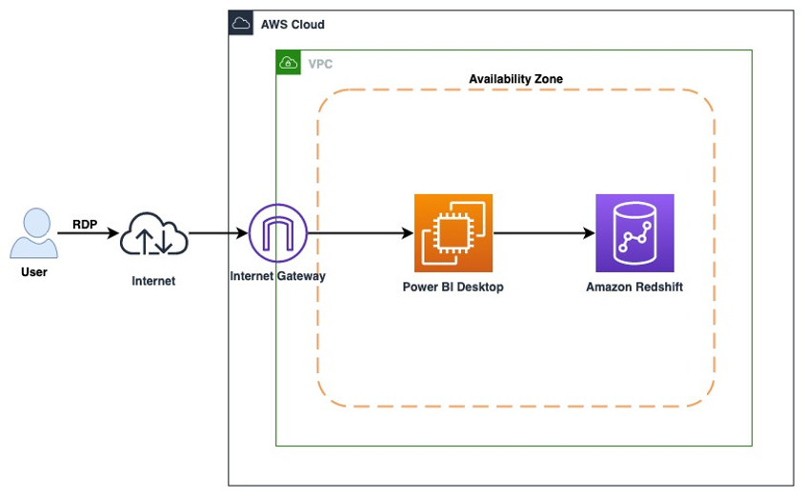

## [Before You Begin](https://catalog.us-east-1.prod.workshops.aws/v2/workshops/9f29cdba-66c0-445e-8cbb-28a092cb5ba7/en-US/lab18" \l "before-you-begin)

This lab assumes you have launched a Redshift cluster. If you have not launched a cluster, see [LAB 1 - Creating Redshift Clusters](https://catalog.us-east-1.prod.workshops.aws/v2/workshops/9f29cdba-66c0-445e-8cbb-28a092cb5ba7/en-US/lab1.html). The lab also assume you can gather the following information. If you have not configured your client tool, see [Lab 1 - Creating Redshift Clusters : Configure Client Tool](https://catalog.us-east-1.prod.workshops.aws/v2/workshops/9f29cdba-66c0-445e-8cbb-28a092cb5ba7/en-US/lab1.html#configure-client-tool).

If you deployed your cluster from [LAB 1 - Creating Redshift Clusters](https://catalog.us-east-1.prod.workshops.aws/v2/workshops/9f29cdba-66c0-445e-8cbb-28a092cb5ba7/en-US/lab1.html) and kept the default credentials, then use awsuser as the username and Awsuser123 as the password for your Redshift cluster.

* [Redshift-Endpoint]
* [Redshift-User]
* [Redshift-Password]
* [Redshift-Port]
* [Redshift-Database]
* [Redshift-Subnet]
* [Redshift-SecurityGroup]
* [Your-Redshift_Role_Arn]

Use the following CloudFormation template to deploy the Windows EC2 instance required for this lab.

**Note: Labs 11, 12, and 18 use the same supplemental CloudFormation template. You can utilize the same issued resources interchangably for these labs.**

[Launch Stack](https://console.aws.amazon.com/cloudformation/home?#/stacks/new?stackName=ImmersionLab2&templateURL=https://s3-us-west-2.amazonaws.com/redshift-immersionday-labs/lab11.yaml)

When you launch the stack, you will have to configure your stack parameters. This will ensure that the DMS Instance and EC2 Instance have connectivity to your Redshift cluster.

* [RedshiftSecurityGroup] - sg-XXXXX
* [RedshiftSubnet] - subnet-XXXXX

Choose the [RedshiftSecurityGroup] that was launched by the Redshift cluster stack. For the [RedshiftSubnet] parameter, ensure you're selecting the two subnets with the 10.0.0.0/24 and 10.0.1.0/24 CIDR ranges.

If this stack is rolling back with a arn:aws:iam::XXX:role/dms-vpc-role is not configured properly error, go ahead and delete this template and re-launch it. It should deploy successfully the second time.

Make sure to launch this CloudFormation template in the US-West-2 or US-East-1 region.

The template will use the default CIDR block of 0.0.0.0/0 for the Windows EC2 instance Security Group which provides access from any IP Address. It is a best practice to restrict this with your IP address or a range of IP addresses which should have access.

Navigate to [AWS CloudFormation](https://console.aws.amazon.com/cloudformation/home) and click on your stack. Note down the EC2Hostname. You’ll need this parameter in subsequent steps.

If you do not have a Remote Desktop client installed, you can use the instructions at this [link](https://docs.aws.amazon.com/AWSEC2/latest/WindowsGuide/connecting_to_windows_instance.html) to do so.

#### [Build your DDL](https://catalog.us-east-1.prod.workshops.aws/v2/workshops/9f29cdba-66c0-445e-8cbb-28a092cb5ba7/en-US/lab18" \l "build-your-ddl)

Navigate to the query editor of your Redshift cluster.In the Redshift query editor, paste and run the following script to define a schema and table.

CREATE SCHEMA workshop_das;

CREATE TABLE workshop_das.green_201601_csv

(

vendorid VARCHAR(4),

pickup_datetime TIMESTAMP,

dropoff_datetime TIMESTAMP,

store_and_fwd_flag VARCHAR(1),

ratecode INT,

pickup_longitude FLOAT4,

pickup_latitude FLOAT4,

dropoff_longitude FLOAT4,

dropoff_latitude FLOAT4,

passenger_count INT,

trip_distance FLOAT4,

fare_amount FLOAT4,

extra FLOAT4,

mta_tax FLOAT4,

tip_amount FLOAT4,

tolls_amount FLOAT4,

ehail_fee FLOAT4,

improvement_surcharge FLOAT4,

total_amount FLOAT4,

payment_type VARCHAR(4),

trip_type VARCHAR(4)

)

DISTSTYLE EVEN

SORTKEY (passenger_count,pickup_datetime);

#### [Build your Copy Command](https://catalog.us-east-1.prod.workshops.aws/v2/workshops/9f29cdba-66c0-445e-8cbb-28a092cb5ba7/en-US/lab18" \l "build-your-copy-command)

* Build your copy command to copy the data from Amazon S3. This dataset has the number of taxi rides in the month of January 2016.

Make sure to replace [Your-Redshift_Role_Arn] value in the script below.

Paste and run the following command to load data into your Redshift table.

COPY workshop_das.green_201601_csv

FROM 's3://us-west-2.serverless-analytics/NYC-Pub/green/green_tripdata_2016-01.csv'

IAM_ROLE '[Your-Redshift_Role_Arn]'

DATEFORMAT 'auto'

IGNOREHEADER 1

DELIMITER ','

IGNOREBLANKLINES

REGION 'us-west-2'

;

Paste and run the following command to determine how many rows you just loaded.

select count(1) from workshop_das.green_201601_csv;

--1445285

## [1. Login to Power BI Desktop](https://catalog.us-east-1.prod.workshops.aws/v2/workshops/9f29cdba-66c0-445e-8cbb-28a092cb5ba7/en-US/lab18" \l "1.-login-to-power-bi-desktop)

In this section we will login to the Windows EC2 instance to launch the Power BI Desktop software. Launch Windows Remote Desktop client (RDP) tool and enter the credentials below to login to the instance.

Remember: You must replace the values between any <> with the values from the CloudFormation outputs tab. Values between any [] indicate parameters that you can receive by navigating to the specific AWS service within the console.

Remote Desktop Host: <EC2HostName>

Username: developer

Password: Password1

Find Microsoft Power BI Desktop icon on the desktop and double click on it to launch the software. Alternatively, you can search for Power BI Desktop in the search box.

## [2. Connecting to Amazon Redshift](https://catalog.us-east-1.prod.workshops.aws/v2/workshops/9f29cdba-66c0-445e-8cbb-28a092cb5ba7/en-US/lab18" \l "2.-connecting-to-amazon-redshift)

Once launched, select Get data button to start the integration process.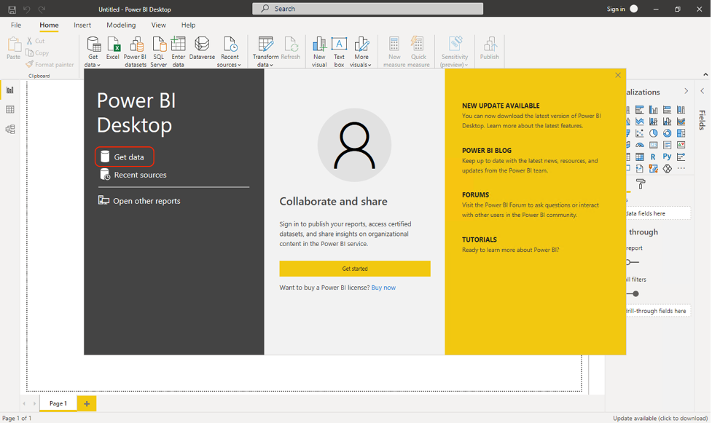

In the Get Data popup, search for Redshift and select Amazon Redshift in the results.

Click on the Connect button.

In the Redshift connection details screen, enter the parameters below and click on OK.

Server: [Redshift-Endpoint]

Database: [Redshift-Database]

Enter the Redshift cluster credentials in below screen and click on Connect button to proceed.

UserName: [Redshift-User]

Password: [Redshift-Password]

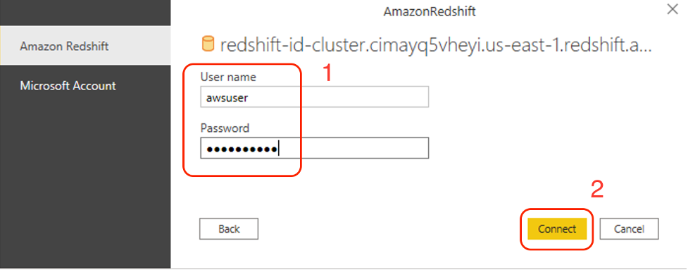

You may get a Connection settings popup. Choose Import to copy over the data.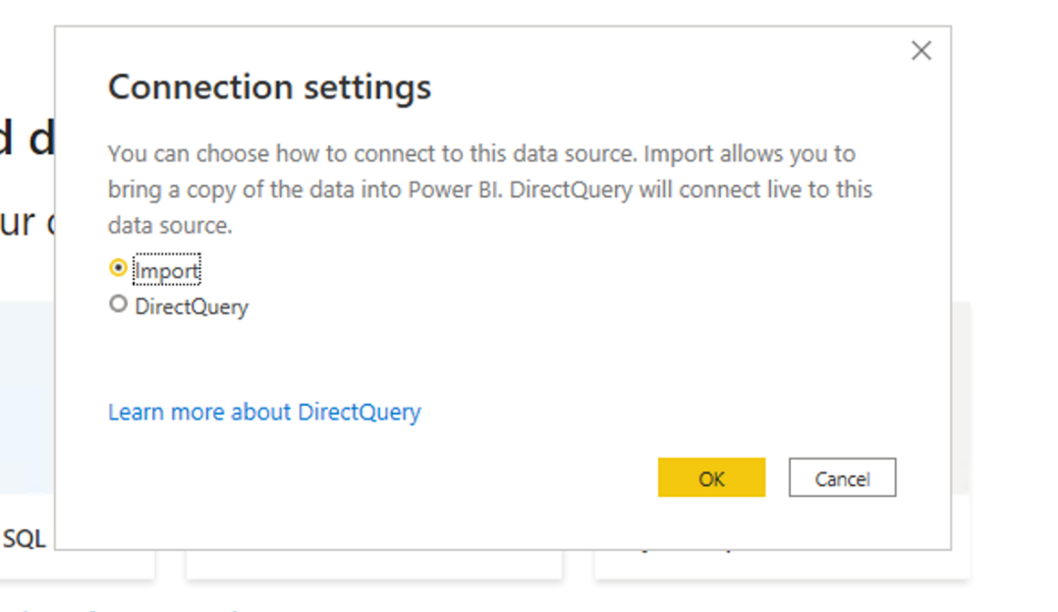

Once the connection is established successfully, the navigator page will list all available Redshift schemas to connect. Select green_201601_csv table under the workshop_das schema and click Load to create visualizations on this data.Afbeelding met tekst, tafel

Power BI Desktop will take few minutes to connect to the Redshift cluster and cache the green company taxi data locally.

## [3. Create Visualizations](https://catalog.us-east-1.prod.workshops.aws/v2/workshops/9f29cdba-66c0-445e-8cbb-28a092cb5ba7/en-US/lab18" \l "3.-create-visualizations)

Now it’s time to get creative and start creating visualizations on the green taxi data. We will create a map visualization with pickup latitude and longitude. Select Map from the Visualizations palette.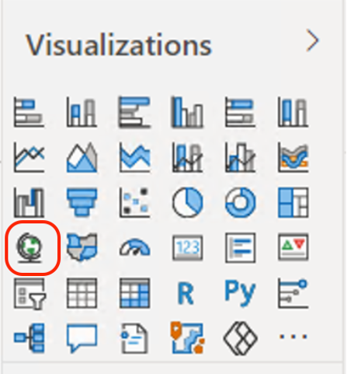

Select pickup_latitude, pickup_longitude fields from the green_201601_csv tables.

In Visualizations Fields section, change the Latitude dropdown value from Average of pickup_latitude to Don’t Summarize. Repeat the same for the Longitude field.

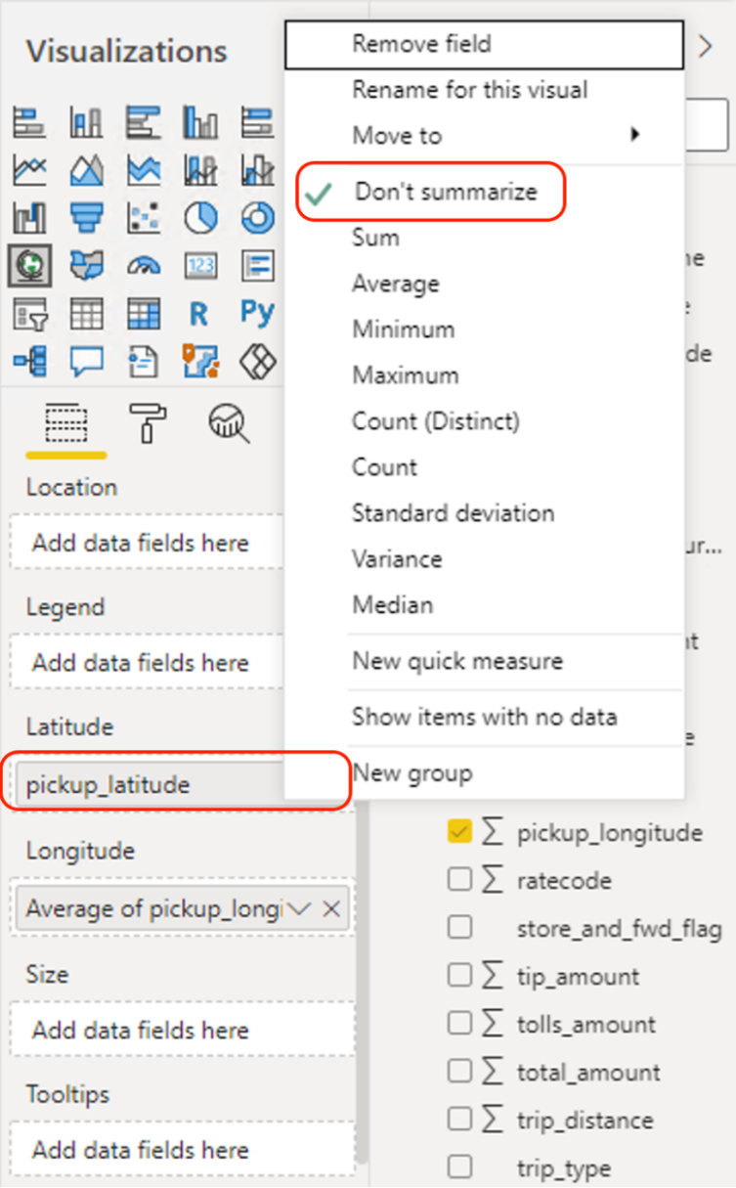

Now, you will see the map populated with pickup points.

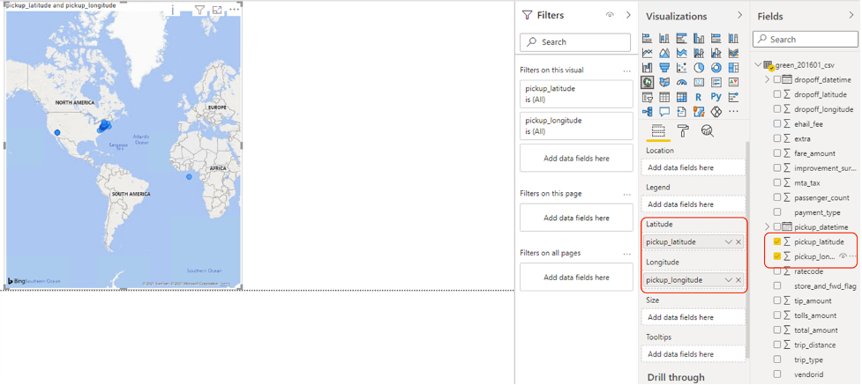

You may need to press Apply Changes to render the visualization.

This is just one example on how you can integrate Redshift data with Power BI Desktop. Feel free to try the other available visualizations.

[Before You Leave](https://catalog.us-east-1.prod.workshops.aws/v2/workshops/9f29cdba-66c0-445e-8cbb-28a092cb5ba7/en-US/lab18" \l "before-you-leave)

If you are done with this lab, consider deleting the CloudFormation template to avoid having to pay for unused resources

# 19. Amazon Sagemaker Data Wrangler

In this lab, we will show you how to prepare the data for Machine Learning using Amazon Sagemaker Data Wrangler. We will analyze and cleanse the data in our Redshift cluster using Data Wrangler before a Machine Learning Model can be trained. Amazon SageMaker Data Wrangler can be accessed from Amazon Sagemaker Studio.

## [Contents](https://catalog.us-east-1.prod.workshops.aws/v2/workshops/9f29cdba-66c0-445e-8cbb-28a092cb5ba7/en-US/lab19" \l "contents)

* [Setup Sagemaker Studio domain and Create new Data Flow](https://catalog.us-east-1.prod.workshops.aws/v2/workshops/9f29cdba-66c0-445e-8cbb-28a092cb5ba7/en-US/lab19#setup-sagemaker-studio-domain-and-create-new-data-flow)
* [Import Data set](https://catalog.us-east-1.prod.workshops.aws/v2/workshops/9f29cdba-66c0-445e-8cbb-28a092cb5ba7/en-US/lab19#import-data-set)
* [Analyze and Visualize](https://catalog.us-east-1.prod.workshops.aws/v2/workshops/9f29cdba-66c0-445e-8cbb-28a092cb5ba7/en-US/lab19#analyze-and-visualize)
* [Drop Unused Columns](https://catalog.us-east-1.prod.workshops.aws/v2/workshops/9f29cdba-66c0-445e-8cbb-28a092cb5ba7/en-US/lab19#drop-unused-columns)
* [Create Dummy Variables](https://catalog.us-east-1.prod.workshops.aws/v2/workshops/9f29cdba-66c0-445e-8cbb-28a092cb5ba7/en-US/lab19#create-dummy-variables)
* [Standardizing Numeric Variables](https://catalog.us-east-1.prod.workshops.aws/v2/workshops/9f29cdba-66c0-445e-8cbb-28a092cb5ba7/en-US/lab19#standardizing-numeric-variables)
* [Export Processed Data](https://catalog.us-east-1.prod.workshops.aws/v2/workshops/9f29cdba-66c0-445e-8cbb-28a092cb5ba7/en-US/lab19#export-processed-data)
* [Before You Leave](https://catalog.us-east-1.prod.workshops.aws/v2/workshops/9f29cdba-66c0-445e-8cbb-28a092cb5ba7/en-US/lab19#before-you-leave)

## [Before You Begin](https://catalog.us-east-1.prod.workshops.aws/v2/workshops/9f29cdba-66c0-445e-8cbb-28a092cb5ba7/en-US/lab19" \l "before-you-begin)

This lab assumes you have launched a Redshift cluster. If you have not launched a cluster, see [LAB 1 - Creating Redshift Clusters](https://catalog.us-east-1.prod.workshops.aws/v2/workshops/9f29cdba-66c0-445e-8cbb-28a092cb5ba7/en-US/lab1.html). The lab also assume you can gather the following information from Clouformation output.

* [Your-Redshift-Cluster]
* [Your-Redshift_Database]
* [Your-Redshift_Username]
* [Your-Redshift_Role_Arn]

## [Setup Sagemaker Studio domain and Create new Data Flow](https://catalog.us-east-1.prod.workshops.aws/v2/workshops/9f29cdba-66c0-445e-8cbb-28a092cb5ba7/en-US/lab19" \l "setup-sagemaker-studio-domain-and-create-new-data-flow)

To create a Sagemaker Studio domain, please follow the steps mentioned in lab 10b [Speed up Machine learning (SageMaker Studio)](https://redshift-immersion.workshop.aws/lab10b.html#setup-sagemaker-studio-domain-and-create-python-notebook) till Add user. After user is created, click Open Studio. The first time you open studio, SageMaker will create the default JupyterServer application and redirect you there, this may take a few minutes. Now you can create your data flow by clicking on New data flow. This creates a new directory in Studio with a .flow file inside, which contains your data flow. The .flow file automatically opens in Studio.Afbeelding met tekst, schermafbeelding, monitor, scherm

Name this flow as Bank_Details.flow

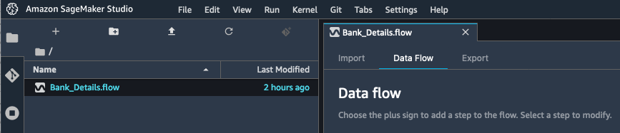

## [Import Data set](https://catalog.us-east-1.prod.workshops.aws/v2/workshops/9f29cdba-66c0-445e-8cbb-28a092cb5ba7/en-US/lab19" \l "import-data-set)

In this step, you will create a connection to Amazon Redshift. Amazon Sagemaker Data Wrangler built in out of the box feature makes it real easy to connect to Amazon Redshift.

On the Import tab of your Bank_Details.flow, click on Add data source and select Amazon Redshift.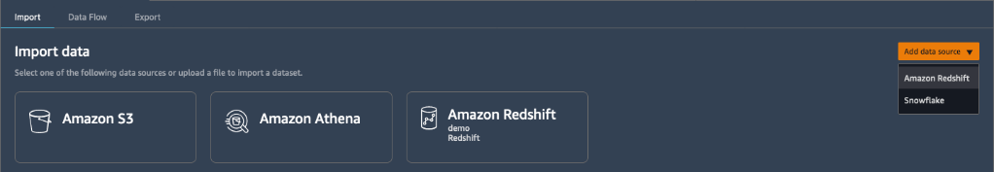

Enter the below Amazon Redshift connection details and click on Connect.

1. Choose Temporary credentials (IAM) for Type.
2. Enter a Connection name. This is the name used by Data Wrangler to identify this connection.
3. Enter the Cluster identifier to specify to which cluster you want to connect.
4. Enter the Database name of the database to which you want to connect to.
5. Enter a Database user to identify the user you want to use to connect to the database.
6. For Unload IAM role, enter the IAM role ARN of the role that the Amazon Redshift cluster should assume to move and write data to Amazon S3.

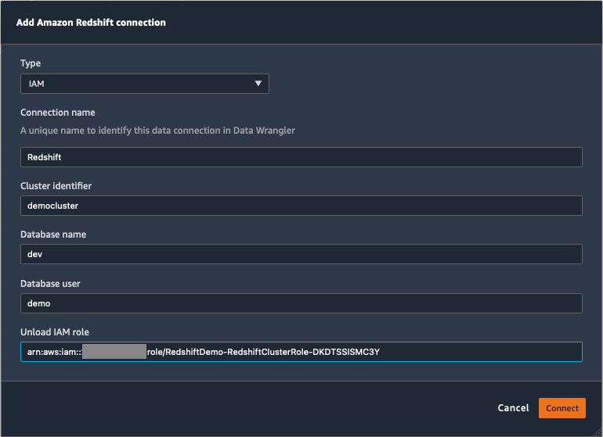

After successful connection to Redshift Cluster a new pane "Query Amazon Redshift" is displayed. Go to Schema and select public schema from drop down list.

1. Type below code in query editor below
2. 1

Select * from bank_details;

1. Click on Run button which is found right above the query editor.
2. After successful return of result set, Import button is activated on top.
3. Click on Import button.
4. Give a name to this data set "bank_details" and click on add button.

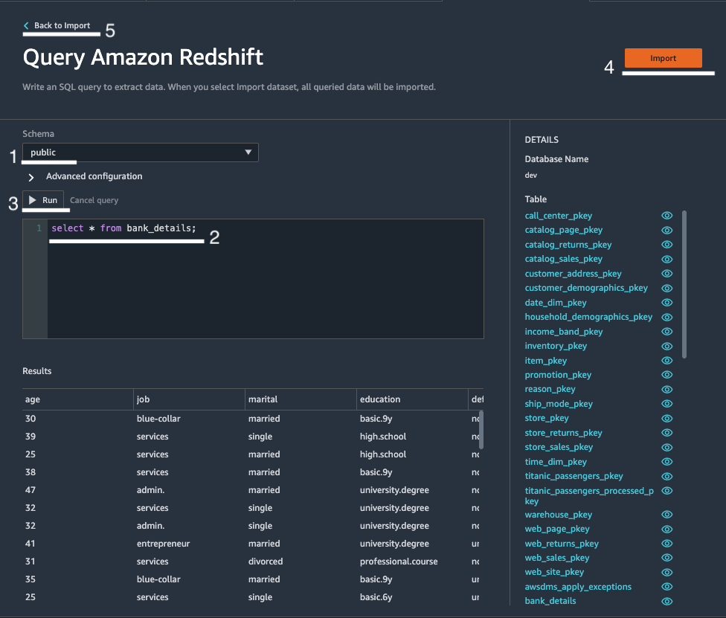

Data wrangler automatically infers the datatype for each column. In this step, you will verify the datatypes of the data set you imported.

Under Data Flow tab

1. Choose + next to the Data types step and select Edit data types.
2. Observe data types that are automatically inferred by data wrangler tool.

3. Click "Back to Data flow" on top right hand side to exit out of here.

## [Analyze and Visualize](https://catalog.us-east-1.prod.workshops.aws/v2/workshops/9f29cdba-66c0-445e-8cbb-28a092cb5ba7/en-US/lab19" \l "analyze-and-visualize)

In this step, you will analyze the data to generate the summary stats for Banking data. Here you can understand demographics about your data for example, what is the average age of the clients.

Under Data Flow tab

1. Choose the + next to the Data types step in your data flow and select Add analysis.
2. Under Create analysis, select Table summary from the Analysis type dropdown list.
3. Give the table summary a Name. For Example, "Summary".
4. Select Preview to preview the table that will be created.
5. Click save to save your Analysis. It appears under Analysis tab.

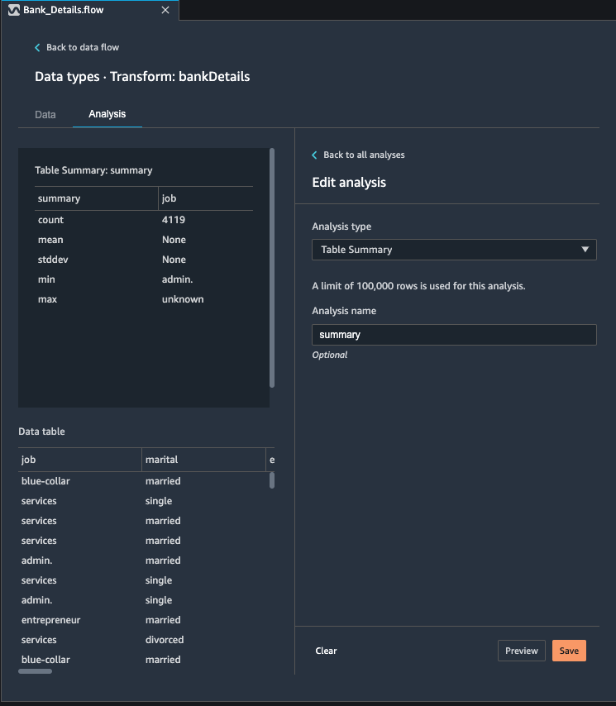

Next, you will now create a histogram to understand how different education levels of different clients is distributed against longer term deposit sign ups. You will use histogram chart to visually inspect if education levels and longer term opt-ins have any uneven distribution. Under Data Flow tab.

1. While still in Analysis tab, click on Create new Analysis button
2. Under Create analysis, select Histogram from the Analysis type dropdown list.
3. Give the Analysis a name. For Example, "Education_Levels_vs_term_signups".
4. In x-axis select “education” from drop down list.
5. Color by – leave empty.
6. Facet by – Select “y” from drop list.
7. Select Preview to preview the histogram that will be created.
8. Click on add to save this analysis. It appears under Analysis tab.

You will observe that clients who have University Degree have most opt ins and clients who have basic education have low number of opt ins.

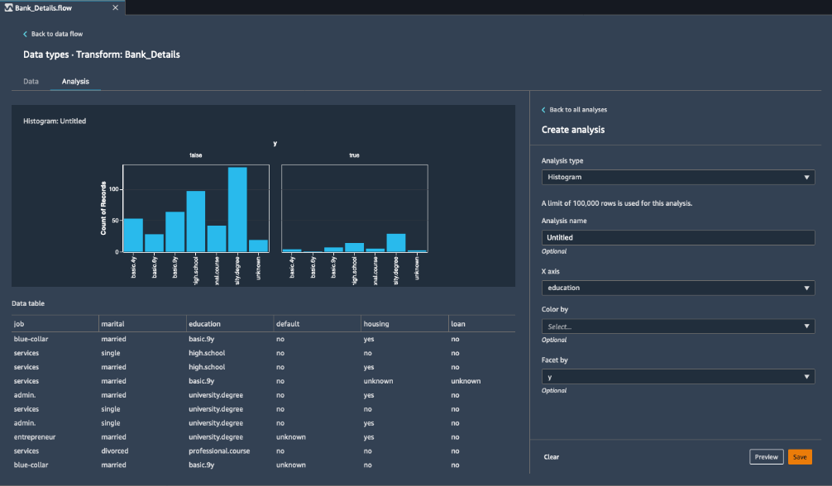

Next, you want to know if there are any missing values in the banking data set, for this you will use custom transformation feature available in Data wrangler tool and apply pandas df.info() method on Banking data set.

Under Data Flow tab.

1. Choose the + next to the Data types step in your data flow and select Add transform.
2. In the Transforms section, click on Add step and select Custom transform.
3. Select Python (Pandas) from drop down list.
4. In the code editor, type
5. 1
6. 2
7. df.info()
8. Select Preview to preview the data that will be displayed below python code editor.
9. Click on Add to save this transformation.

## [Drop Unused Columns](https://catalog.us-east-1.prod.workshops.aws/v2/workshops/9f29cdba-66c0-445e-8cbb-28a092cb5ba7/en-US/lab19" \l "drop-unused-columns)

In this step, you will drop the fields that are not required in your analysis especially socio-economic fields and other campaign related fields such as day_of_week, duration, emp.var.rate, cons.price.idx, euribor3m, nr.employed.

Under Data Flow tab.

1. Choose the + next to the Custom Pandas step in your data flow and select Add Transform.
2. In the Transforms section, select Add step.
3. Select Custom transform.
4. Select Python (Pandas) from drop down list.
5. Enter the following in the code box. Below columns will be dropped from dataset.
6. 1
7. 2
8. 3
9. 4
10. cols = ['day_of_week', 'duration', 'emp_var_rate', 'cons_price_idx', 'cons_conf_idx', 'euribor3m','nr_employed']

df = df.drop(cols, axis=1)

1. Click on Preview and then click on add to save it.

A new transformation step is now added to the flow.  
Under data preview you can notice that these fields are now not displayed anymore.

Tip: Data Wrangler has built in transformation to drop columns. To use the built-in transformations, under transformation: Choose Manage columns from the right panel. For Input column, choose the column that you want drop, and choose Preview. Verify that the column is has been dropped, then choose Add.

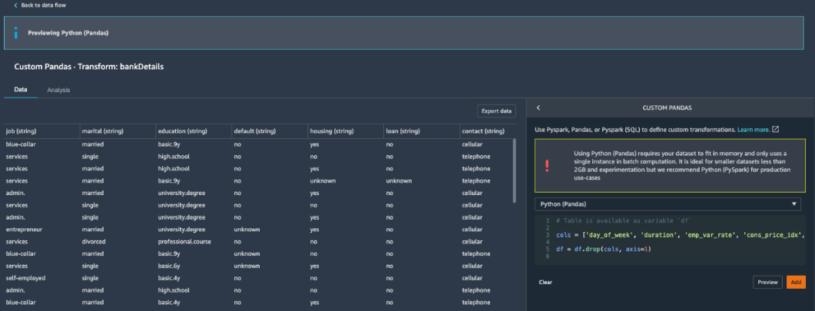

1. Click on Back to data flow to exit out of here.

## [Create Dummy Variables](https://catalog.us-east-1.prod.workshops.aws/v2/workshops/9f29cdba-66c0-445e-8cbb-28a092cb5ba7/en-US/lab19" \l "create-dummy-variables)

In this step, you will create dummy variables in banking data set. You will use Data wrangler's built in encoding feature to create reference variables. You can create dummy variables for following Categorical Variables: job, marital, education, default, housing, loan, contact, and month. For this lab we will create it for marital.

Under Data Flow tab.

1. Choose the + next to the Steps(n) step in your data flow and select Add Transform.
2. In the Transforms section, Click on Add Step
3. Now select Encode Categorical.
4. Under Transform: Select one-hot encode from drop down list.
5. Under Input Column: Select marital from drop down list.
6. Under Invalid Handling Strategy: Select Skip.
7. Under Output style: Select Columns from drop down list.
8. Click on preview and you notice that new reference variables are created for Marital field. You can view them under Data tab and scroll all the way to the right.
9. Click on Add to save this transform.
10. Click on back to data flow to exit out of here.

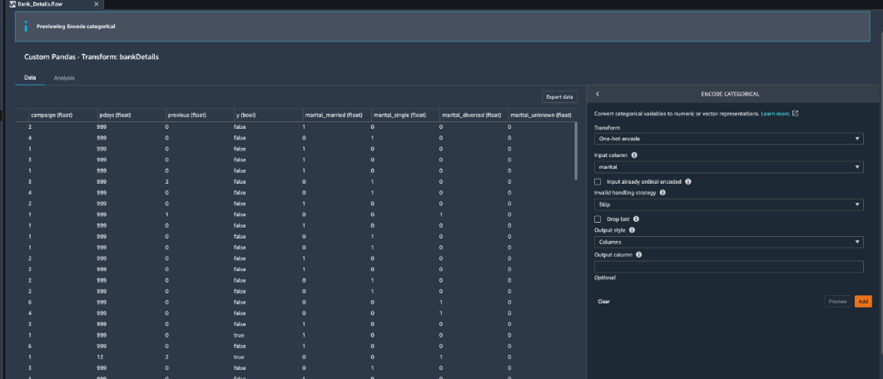

## [Standardizing Numeric Variables](https://catalog.us-east-1.prod.workshops.aws/v2/workshops/9f29cdba-66c0-445e-8cbb-28a092cb5ba7/en-US/lab19" \l "standardizing-numeric-variables)

In this step, you will standardize the numeric datatype fields. For example, let's assume that you are going to use Gradient descent algorithm to work on feature scaling.

You will notice that age, campaign, previous, pdays columns are of numeric type that need to go through standardization process. You will use Data Wrangler's built in transformation "Process Numeric".

Under Data Flow tab.

1. Choose the + next to the Steps(n) step in your data flow and select Add Transform.
2. In the Transforms section, Click on Add Step
3. Create new transformation by using built in Process Numeric transformation.
4. Under Transform: select Scale values from drop down.
5. Under Scaler: Select Standard scaler from the drop down.
6. Under Input Column: Select age from the drop down. And click on Center check box as measure of standardization.
7. Click on preview and you notice that age field is scaled now. Click on Add to save it.
8. For this lab you can continue with rest of the numeric fields or skip standardizing other numeric variables and move onto next step.
9. Click on Back to data flow to exit out of here

* Notice that age values are now standardized.

## [Export Processed Data](https://catalog.us-east-1.prod.workshops.aws/v2/workshops/9f29cdba-66c0-445e-8cbb-28a092cb5ba7/en-US/lab19" \l "export-processed-data)

In this step, you will export the data set that you analyzed and standardized in the previous steps. You can use this exported data in Redshift Machine learning to train a classification model.

Under Data Flow tab.

1. Click on Steps(n) from the listed list, select last step. In this lab it is Scale Values. Last step contains all the transformations that we added to the flow and are applied on data.

1. Under Data tab,click on Export data option.
2. Provide a S3 bucket to which Redshift cluster role has access to.
3. Set file type as CSV, Delimiter as Comma and Compression as None.

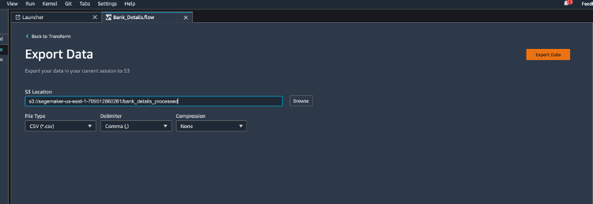

You now have machine learning ready data on s3.

You can utilize Redshift ML or Amazon Sagemaker Studio to train a machine learning model on this data.

## [Before You Leave](https://catalog.us-east-1.prod.workshops.aws/v2/workshops/9f29cdba-66c0-445e-8cbb-28a092cb5ba7/en-US/lab19" \l "before-you-leave)

If you are done using your cluster, please think about decommissioning it to avoid having to pay for unused resources

# 20. Use Lambda UDFs to translate and analyze text

## [Contents](https://catalog.us-east-1.prod.workshops.aws/v2/workshops/9f29cdba-66c0-445e-8cbb-28a092cb5ba7/en-US/lab20" \l "contents)

* [Overview](https://catalog.us-east-1.prod.workshops.aws/v2/workshops/9f29cdba-66c0-445e-8cbb-28a092cb5ba7/en-US/lab20#overview)
* [Architecture](https://catalog.us-east-1.prod.workshops.aws/v2/workshops/9f29cdba-66c0-445e-8cbb-28a092cb5ba7/en-US/lab20#architecture)
* [Install](https://catalog.us-east-1.prod.workshops.aws/v2/workshops/9f29cdba-66c0-445e-8cbb-28a092cb5ba7/en-US/lab20#install)
* [Cost](https://catalog.us-east-1.prod.workshops.aws/v2/workshops/9f29cdba-66c0-445e-8cbb-28a092cb5ba7/en-US/lab20#cost)
* [Run your first text analytics queries](https://catalog.us-east-1.prod.workshops.aws/v2/workshops/9f29cdba-66c0-445e-8cbb-28a092cb5ba7/en-US/lab20#run-your-first-text-analytics-queries)
* [Configure Amazon Redshift Spectrum and create external schema](https://catalog.us-east-1.prod.workshops.aws/v2/workshops/9f29cdba-66c0-445e-8cbb-28a092cb5ba7/en-US/lab20#configure-amazon-redshift-spectrum-and-create-external-schema)
* [Access Amazon product reviews dataset](https://catalog.us-east-1.prod.workshops.aws/v2/workshops/9f29cdba-66c0-445e-8cbb-28a092cb5ba7/en-US/lab20#access-amazon-product-reviews-dataset)
* [Detect the language for each review](https://catalog.us-east-1.prod.workshops.aws/v2/workshops/9f29cdba-66c0-445e-8cbb-28a092cb5ba7/en-US/lab20#detect-the-language-for-each-review)
* [Translate all reviews into one language](https://catalog.us-east-1.prod.workshops.aws/v2/workshops/9f29cdba-66c0-445e-8cbb-28a092cb5ba7/en-US/lab20#translate-all-reviews-into-one-language)
* [Detect sentiment and entities for each review](https://catalog.us-east-1.prod.workshops.aws/v2/workshops/9f29cdba-66c0-445e-8cbb-28a092cb5ba7/en-US/lab20#detect-sentiment-and-entities-for-each-review)
* [Prepare sentiment for analysis](https://catalog.us-east-1.prod.workshops.aws/v2/workshops/9f29cdba-66c0-445e-8cbb-28a092cb5ba7/en-US/lab20#prepare-sentiment-for-analysis)
* [Prepare entities for analysis](https://catalog.us-east-1.prod.workshops.aws/v2/workshops/9f29cdba-66c0-445e-8cbb-28a092cb5ba7/en-US/lab20#prepare-entities-for-analysis)
* [Visualize in Amazon QuickSight - OPTIONAL](https://catalog.us-east-1.prod.workshops.aws/v2/workshops/9f29cdba-66c0-445e-8cbb-28a092cb5ba7/en-US/lab20#visualize-in-amazon-quickSight)
* [Conclusion](https://catalog.us-east-1.prod.workshops.aws/v2/workshops/9f29cdba-66c0-445e-8cbb-28a092cb5ba7/en-US/lab20#conclusion)

## [Before You Begin](https://catalog.us-east-1.prod.workshops.aws/v2/workshops/9f29cdba-66c0-445e-8cbb-28a092cb5ba7/en-US/lab20" \l "before-you-begin)

This lab assumes you have launched a Redshift cluster, configured your client tool. If you have not launched a cluster, see [LAB 1 - Creating Redshift Clusters](https://catalog.us-east-1.prod.workshops.aws/v2/workshops/9f29cdba-66c0-445e-8cbb-28a092cb5ba7/en-US/lab1.html). If you have not configured your client tool, see [Lab 1 - Creating Redshift Clusters : Configure Client Tool](https://catalog.us-east-1.prod.workshops.aws/v2/workshops/9f29cdba-66c0-445e-8cbb-28a092cb5ba7/en-US/lab1.html#configure-client-tool). For this lab, you will need to gather the following information about your cluster from [LAB 1 - Creating Redshift Clusters](https://catalog.us-east-1.prod.workshops.aws/v2/workshops/9f29cdba-66c0-445e-8cbb-28a092cb5ba7/en-US/lab1.html).

* [Your-Redshift_Role_Arn]

This lab requires a cluster in the US-WEST-2 (Oregon) region.

## [Overview](https://catalog.us-east-1.prod.workshops.aws/v2/workshops/9f29cdba-66c0-445e-8cbb-28a092cb5ba7/en-US/lab20" \l "overview)

Amazon Redshift allows you to create AWS Lambda User Defined Functions (UDFs) which you can use in your SQL queries. Lambda UDFs enable you to write custom data processing functions which can potentially integrate with external services. You can create Lambda UDFs in any of the programming languages supported by Lambda

In this lab, you will use a set of pre-built Amazon Redshift Lambda UDFs which integrate with Amazon Translate and Amazon Comprehend to provide the following text analytics capabilities:

* Detect the dominant language of a text field
* Detect the prevailing sentiment expressed—positive, negative, neither, or both
* Detect or redact entities (such as items, places, or quantities)
* Detect or redact PII
* Translate text from one language to another, using Amazon Translate

For more information on different use-cases, refer to:

* [Translate, redact, and analyze text using SQL functions with Amazon Redshift, Amazon Translate, and Amazon Comprehend](http://www.amazon.com/redshift-textanalyticsudf)

## [Architecture](https://catalog.us-east-1.prod.workshops.aws/v2/workshops/9f29cdba-66c0-445e-8cbb-28a092cb5ba7/en-US/lab20" \l "architecture)

We will use pre-built [Aws Lambda](https://aws.amazon.com/lambda/) functions to invoke [Amazon Comprehend](https://aws.amazon.com/comprehend/) APIs to detect [language](https://docs.aws.amazon.com/comprehend/latest/dg/API_BatchDetectDominantLanguage.html) or [sentiment](https://docs.aws.amazon.com/comprehend/latest/dg/API_BatchDetectSentiment.html), and to detect or redact [entities](https://docs.aws.amazon.com/comprehend/latest/dg/API_BatchDetectEntities.html) and [Personally Identifiable Information (PII)](https://docs.aws.amazon.com/comprehend/latest/dg/API_DetectPiiEntities.html) from text fields. It also uses [Amazon Translate](https://aws.amazon.com/translate/) for language translation.

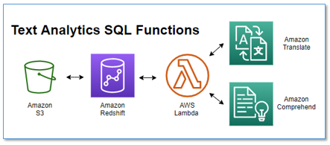

## [Install](https://catalog.us-east-1.prod.workshops.aws/v2/workshops/9f29cdba-66c0-445e-8cbb-28a092cb5ba7/en-US/lab20" \l "install)

Install the prebuilt Lambda function with the following steps:

1. Navigate to the [RedshiftTextAnalyticsUDF](https://console.aws.amazon.com/lambda/home?#/create/app?applicationId=arn:aws:serverlessrepo:us-east-1:777566285978:applications/RedshiftTextAnalyticsUDF) application in the AWS Serverless Application Repository.
2. In the **Application settings** section, keep the settings at their defaults.
3. Select **I acknowledge that this app creates custom IAM roles**.
4. Choose **Deploy**.

5. When the application has deployed, choose the application **Deployments** tab and then **CloudFormation stack**.

6. Choose the stack **Outputs** tab.

7. Select the ARN that is shown as the value of the output labeled RedshiftLambdaInvokeRole and copy to the clipboard. 8. On the Amazon Redshift console, in the navigation menu, choose **CLUSTERS**, then choose the name of the cluster that you want to update. 9. For Actions, choose **Manage IAM roles**. 10. Choose **Enter ARN** and enter the ARN for the role that you copied earlier. 11. Choose **Associate IAM role** to add it to the list of **Attached IAM roles**. 12. Choose **Save changes** to associate the IAM role with the cluster. 13. Select the SQL code that is shown as the value of the output labeled SQLScriptExternalFunction and copy to the clipboard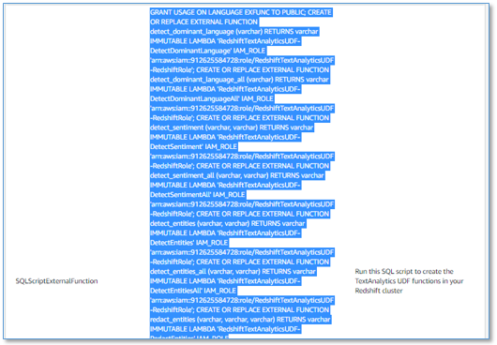

14. Paste this SQL into your Redshift SQL editor, and run it on your Amazon Redshift database as an admin user.

And that’s it! Now you have a suite of new Lambda backed text analytics functions. You’re ready to try some text analytics queries in Amazon Redshift.

NOTE: Alternatively, you can build and deploy the UDFs from the source code - see the directions in the [GitHub repository README](https://github.com/aws-samples/aws-redshift-udfs-textanalytics/blob/main/README.md#build-and-install-udf-from-source).

## [Cost](https://catalog.us-east-1.prod.workshops.aws/v2/workshops/9f29cdba-66c0-445e-8cbb-28a092cb5ba7/en-US/lab20" \l "cost)

In addition to Amazon Redshift costs, the text analytics UDF incurs usage costs from Amazon Comprehend and Amazon Translate. The amount you pay is a factor of the total number of records and characters that you process with the UDF. For more information, see the section titled Optimize cost in the [blog post](http://www.amazon.com/redshift-textanalyticsudf). To minimize the costs, avoid processing the same records multiple times. Instead, materialize the results of the text analytics UDF in a table that you can then cost-effectively query as often as needed without incurring additional UDF charges.

## [Run your first text analytics queries](https://catalog.us-east-1.prod.workshops.aws/v2/workshops/9f29cdba-66c0-445e-8cbb-28a092cb5ba7/en-US/lab20" \l "run-your-first-text-analytics-queries)

Enter the following query into the SQL editor

SELECT f_detect_sentiment('I am very happy with this product', 'en') as sentiment;

You get a simple **POSITIVE** result. Now try again, varying the input text. Try something less positive to see how the returned sentiment value changes.

SELECT f_detect_sentiment('I am extremely frustrated with this seller.', 'en') as sentiment;

The above query yields a **NEGATIVE** sentiment. Let us now take a deeper look at how the sentiment is derived. For that, let us use the ***f_detect_sentiment_all*** function call which will give us the confidence scores for each potential sentiment value.

SELECT f_detect_sentiment_all('I am very happy with this product', 'en') as sentiment;

The result is a JSON string with the sentiment and confidence scores.

{

"sentiment": "POSITIVE",

"sentimentScore": {

"positive": 0.99981767,

"negative": 5.033472E-5,

"neutral": 7.5651784E-5,

"mixed": 5.64253E-5

}

}

Later in this lab you will see how to use Amazon Redshift's support for semi-structured data on this JSON result to extract the fields for further analysis.

Here are a few additional simple examples you can try, to give you a sense for what you can do with this technique:

**Detect PII**

SELECT f_detect_pii_entities('I am Bob, I live in Herndon VA, and I love cars', 'en') as pii

Results:

pii

[["NAME","Bob"],["ADDRESS","Herndon VA"]]

**Redact PII**

SELECT f_redact_pii_entities('I am Bob, I live in Herndon VA, and I love cars', 'en', 'NAME,ADDRESS') as pii_redacted

Results:

pii_redacted

I am [NAME], I live in [ADDRESS], and I love cars

**Translate text** (using Amazon Translate):

SELECT f_translate_text('It is a beautiful day in the neighborhood', 'auto', 'fr', 'null') as translated_text

Results:

translated_text

C'est une belle journée dans le quartier

These are just illustrative examples. For the complete set of functions see the [GitHub README](https://github.com/aws-samples/aws-redshift-udfs-textanalytics/blob/main/README.md#functions)

Now that you have some familiarity running the UDF functions, let us cover some real-world usecases of text analysis - we will analyze insights from Amazon customer product reviews.

## [Configure Amazon Redshift Spectrum and create external schema](https://catalog.us-east-1.prod.workshops.aws/v2/workshops/9f29cdba-66c0-445e-8cbb-28a092cb5ba7/en-US/lab20" \l "configure-amazon-redshift-spectrum-and-create-external-schema)

Now you will set up Amazon Spectrum on your cluster, and create an external schema so you can access the Amazon reviews dataset on S3. Skip this section if you have previously configured Amazon Redshift Spectrum on your Amazon Redshift cluster.

1. On the IAM console, in the navigation pane, choose **Roles**.
2. Choose **Create role**.
3. Choose **AWS service**, then choose **Redshift**.
4. Under **Select your use case**, choose **Redshift – Customizable**, then choose **Next: Permissions**.
5. On the **Attach permissions** policy page, choose the policies AmazonS3ReadOnlyAccess, AWSGlueConsoleFullAccess, and AmazonAthenaFullAccess.
6. Choose **Next: Review**.
7. For **Role name**, enter a name for your role, for example mySpectrumRole.
8. Review the information, then choose **Create role**.
9. In the navigation pane, choose **Roles**.
10. Choose the name of your new role to view the summary, then copy the **Role ARN** to your clipboard.

This value is the Amazon Resource Name (ARN) for the role that you just created. You use that value when you create external tables to reference your data files on Amazon S3. 11. On the Amazon Redshift console, in the navigation menu, choose **CLUSTERS**, then choose the name of the cluster that you want to update. 12. For **Actions**, choose **Manage IAM roles**. The IAM roles page appears. 13. Choose **Enter ARN** and enter the ARN for the role that you copied earlier. 14. Choose **Add IAM role** to add it to the list of **Attached IAM roles**. 15. Choose **Save changes** to associate the IAM role with the cluster. The cluster is modified to complete the change. 16. To create an external schema called spectrum, replace the IAM role ARN in the following command with the role ARN of your Redshift Cluster which has permissions to read from S3. Then run the following SQL statement on your Amazon Redshift cluster using your SQL client:

CREATE EXTERNAL SCHEMA spectrum

FROM data catalog

DATABASE 'spectrum'

IAM_ROLE '[Your-Redshift_Role_Arn]'

CREATE EXTERNAL DATABASE IF NOT EXISTS;

## [Access Amazon product reviews dataset](https://catalog.us-east-1.prod.workshops.aws/v2/workshops/9f29cdba-66c0-445e-8cbb-28a092cb5ba7/en-US/lab20" \l "access-amazon-product-reviews-dataset)

You will use the [Amazon Customer Reviews Dataset](https://s3.amazonaws.com/amazon-reviews-pds/readme.html), conveniently hosted for public access in Amazon S3.

1. Create an external table by running the following SQL statement on your Amazon Redshift cluster:

CREATE EXTERNAL TABLE spectrum.amazon_reviews_parquet(

marketplace VARCHAR,

customer_id VARCHAR,

review_id VARCHAR,

product_id VARCHAR,

product_parent VARCHAR,

product_title VARCHAR,

star_rating int,

helpful_votes int,

total_votes int,

vine VARCHAR,

verified_purchase VARCHAR,

review_headline VARCHAR(max),

review_body VARCHAR(max),

review_date bigint,

year int)

ROW FORMAT SERDE

'org.apache.hadoop.hive.ql.io.parquet.serde.ParquetHiveSerDe'

STORED AS INPUTFORMAT

'org.apache.hadoop.hive.ql.io.parquet.MapredParquetInputFormat'

OUTPUTFORMAT

'org.apache.hadoop.hive.ql.io.parquet.MapredParquetOutputFormat'

LOCATION

's3://redshift-immersionday-labs/data/amazon-reviews/'

1. In your Amazon Redshift SQL editor, run the following query to copy review from 2006 to an Amazon Redshift internal table with text in the review body:

CREATE TABLE amazon_reviews_enriched diststyle ALL AS

SELECT *

FROM spectrum.amazon_reviews_parquet

where not review_body is null and year = 2006

## [Detect the language for each review](https://catalog.us-east-1.prod.workshops.aws/v2/workshops/9f29cdba-66c0-445e-8cbb-28a092cb5ba7/en-US/lab20" \l "detect-the-language-for-each-review)

To detect the language of each review, run the following query in the Amazon Redshift query editor. It takes about 10 seconds to run:

ALTER TABLE amazon_reviews_enriched ADD COLUMN language VARCHAR(8);

CREATE TABLE #amazon_reviews_enriched AS

SELECT review_id, f_detect_dominant_language(review_body) AS language

FROM amazon_reviews_enriched

where review_body is not null;

UPDATE amazon_reviews_enriched t

SET language = s.language

from #amazon_reviews_enriched s

where s.review_id = t.review_id;

The first query creates a new column, language. The second query populates it with the results of the new UDF, f_detect_dominant_language().

Run the following query to see the detected language codes, with the corresponding count of reviews for each language:

1

SELECT language, count(*) AS count FROM amazon_reviews_enriched GROUP BY language ORDER BY count DESC

10 of the reviews have been written in Spanish (es), 2 of the reviews have been written in German (de), and 1 of the reviews have been written in Italian (it).

## [Translate all reviews into one language](https://catalog.us-east-1.prod.workshops.aws/v2/workshops/9f29cdba-66c0-445e-8cbb-28a092cb5ba7/en-US/lab20" \l "translate-all-reviews-into-one-language)

Our analysis will be easier if the reviews are all normalized into a common language. Run the following SQL to create and populate a new column with the English version of all reviews. It takes around 10 seconds to run.

ALTER TABLE amazon_reviews_enriched ADD COLUMN review_body_en VARCHAR(max);

UPDATE amazon_reviews_enriched set review_body_en = review_body where language = 'en';

UPDATE amazon_reviews_enriched

SET review_body_en = f_translate_text(review_body, language, 'en', 'null')

WHERE language <> 'en';

The first statement creates a new column, review_body_en. The second statement populates it with the results of the new UDF, f_translate_text().

Run the following query to see a few of the reviews translated from the original language to English:

SELECT language, review_body, review_body_en FROM amazon_reviews_enriched

WHERE language <> 'en'

## [Detect sentiment and entities for each review](https://catalog.us-east-1.prod.workshops.aws/v2/workshops/9f29cdba-66c0-445e-8cbb-28a092cb5ba7/en-US/lab20" \l "detect-sentiment-and-entities-for-each-review)

To detect sentiment, run the following SQL statements - they use two text analytics functions, and take around 25 seconds to run:

ALTER TABLE amazon_reviews_enriched ADD COLUMN sentiment SUPER;

ALTER TABLE amazon_reviews_enriched ADD COLUMN entities SUPER;

DROP TABLE IF EXISTS #amazon_reviews_enriched;

CREATE TABLE #amazon_reviews_enriched AS

SELECT review_id,

JSON_PARSE(f_detect_sentiment_all(review_body_en, 'en')) sentiment,

JSON_PARSE(f_detect_entities_all(review_body_en, 'en')) entities

FROM amazon_reviews_enriched;

UPDATE amazon_reviews_enriched t

SET sentiment = s.sentiment,

entities = s.entities

from #amazon_reviews_enriched s

where s.review_id = t.review_id;

You just added two additional columns, sentiment and entities, each using the Amazon Redshift semi-structured data type SUPER. For more information, see [Ingesting and querying semistructured data in Amazon Redshift](https://docs.aws.amazon.com/redshift/latest/dg/super-overview.html).

The UPDATE query passes the English translation of each review to the new UDF functions f_detect_sentiment_all() and f_detect_entities_all(). These functions return JSON strings, which the query parses and stores in the new columns.

Inspect some of the values for the new sentiment and entities columns:

SELECT sentiment, entities FROM amazon_reviews_enriched LIMIT 5

As expected, they contain nested structures and fields containing the results from Amazon Comprehend.

Next, let’s use the support in Amazon Redshift for semi-structured data to prepare these columns for analysis.

## [Prepare sentiment for analysis](https://catalog.us-east-1.prod.workshops.aws/v2/workshops/9f29cdba-66c0-445e-8cbb-28a092cb5ba7/en-US/lab20" \l "prepare-sentiment-for-analysis)

Run the following SQL query to create a new table containing sentiment and sentiment scores expanded into separate columns:

SET enable_case_sensitive_identifier to TRUE;

DROP TABLE IF EXISTS sentiment_results_final;

CREATE TABLE sentiment_results_final AS

SELECT

review_date, year, product_title, star_rating, language,

sentiment."sentiment" AS sentiment,

sentiment."sentimentScore"."positive" AS positive_score,

sentiment."sentimentScore"."negative" AS negative_score,

sentiment."sentimentScore"."neutral" AS neutral_score,

sentiment."sentimentScore"."mixed" AS mixed_score,

review_headline, review_body_en

FROM amazon_reviews_enriched

Preview the new sentiment_results_final table. Does the sentiment generally align with the text of the review_body field? How does it correlate with the star_rating? If you spot any dubious sentiment assignments, check the confidence scores to see if the sentiment was assigned with a low confidence.

SELECT * FROM sentiment_results_final WHERE star_rating <= 2 LIMIT 10

SELECT * FROM sentiment_results_final WHERE star_rating >= 4 LIMIT 10

## [Prepare entities for analysis](https://catalog.us-east-1.prod.workshops.aws/v2/workshops/9f29cdba-66c0-445e-8cbb-28a092cb5ba7/en-US/lab20" \l "prepare-entities-for-analysis)

Run the following Amazon Redshift SQL query to create a new table containing detected entities unnested into separate rows, with each field in a separate column:

DROP TABLE IF EXISTS entities_results_final;

CREATE TABLE entities_results_final AS

SELECT

r.review_date, r.year, r.product_title, r.star_rating, r.language,

e."text" AS entity,

e."type" category,

e."score" AS score,

e."beginOffset" AS beginoffset,

e."endOffset" AS endoffset,

r.review_headline, r.review_body_en

FROM amazon_reviews_enriched r, r.entities e

Preview the contents of the new table, entities_results_final:

SELECT product_title, entity, category, score, beginoffset, endoffset, review_body_en

FROM entities_results_final ORDER BY product_title, beginoffset

LIMIT 20

## [Visualize in Amazon QuickSight](https://catalog.us-east-1.prod.workshops.aws/v2/workshops/9f29cdba-66c0-445e-8cbb-28a092cb5ba7/en-US/lab20" \l "visualize-in-amazon-quicksight)

As an optional step, you can visualize your results with [Amazon QuickSight](https://aws.amazon.com/quicksight). For guidance, see [Step 5: Visualizing Amazon Comprehend Output in Amazon QuickSight](https://docs.aws.amazon.com/comprehend/latest/dg/tutorial-reviews-visualize.html).

You can use the new word cloud visual type for entities, instead of tree map. In the word cloud chart menu, select **Hide “other” categories**.

You now have a dashboard with sentiment and entities visualizations that looks similar to the following screenshot.

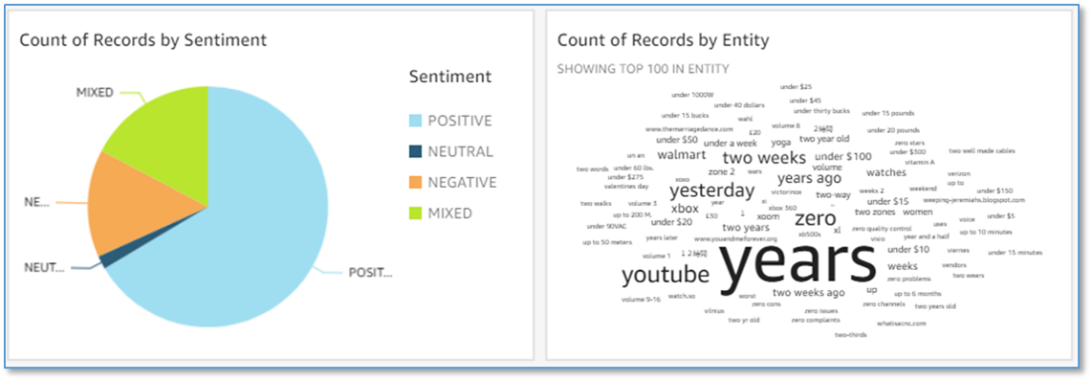

## [Conclusion](https://catalog.us-east-1.prod.workshops.aws/v2/workshops/9f29cdba-66c0-445e-8cbb-28a092cb5ba7/en-US/lab20" \l "conclusion)

Using Redshift Lambda UDFs, you have sucessfully employed Amazon Translate and Amazon Comprehend to translate language, detect sentiment and extract entities from the Amazon product reviews data, and you have prepared the data in tabular form ready to consume in reports and dashboards (such as Amazon Quicksight).

For more information on text analyis in Redshift, check out the blog post:  
[Translate, redact, and analyze text using SQL functions with Amazon Redshift, Amazon Translate, and Amazon Comprehend](http://www.amazon.com/redshift-textanalyticsudf)

With that, we have come to the end of the "Redshift Text Analytics UDFs" lab.